Bug Report Template

Bug ID:
Posts_Replies – [1]
Title:
Sub-Replies not displayed
Environment:
Browser: Chrome – All Browsers
OS: Windows
Device: Desktop
Build/Version: 1.0
Preconditions:
1. Have a registered Verse by Verse Account
2. Have a community created or joined
3. Have a post created
Steps to Reproduce:
1. Sign in to Verse By Verse
2. Navigate to /community
3. Click on a post
4. Post a reply
5. Click “Reply” button to create a sub-reply
Expected Result:
- There should be a “View reply” button to show all of the sub-replies that lives under the reply list
- Reply count – the number of replies displayed in the brackets should increment by 1

Actual Result:
Reply count increments by 1, but user is unable to see the sub-replies
Severity:
Critical
Priority:
High
Status:
Closed
Attachments:
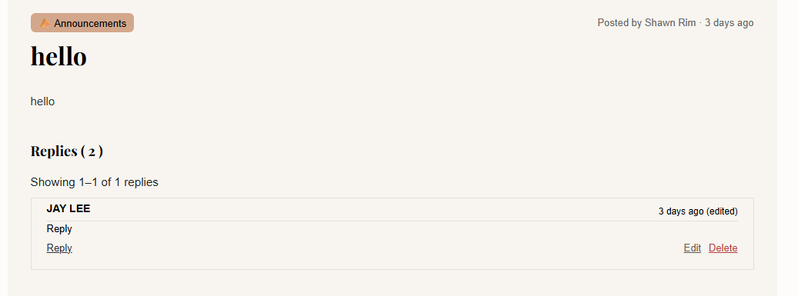Notes / Root Cause (Optional):

